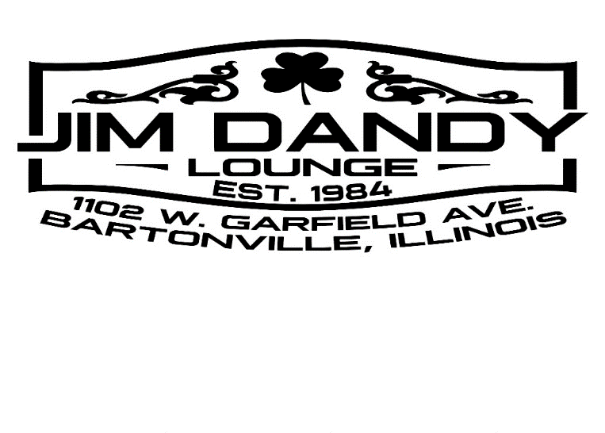
Golf Outing to Benefit Easterseals of Central Illinois
July 10, 2026
Coyote Creek Golf Club

Four person scramble $700 per team
Includes green fee, cart, chance to win a car, drink tickets, raffle tickets, prizes and dinner
(discount of $60 per Coyote Creek member)

12:30 Shotgun Start
5:30 Dinner, Drinks and Prizes at Jim Dandy Lounge

$175 or $115 for CC members

Player 1__________________________________________ $____________

Cell phone or email_______________________________

Player 2__________________________________________ $____________

Player 3__________________________________________ $____________

Player 4__________________________________________ $____________

Sponsorship – See page 2 Type__________________ $____________

Total Fees $____________

Make check payable to: Easterseals Please return by June 30, 2026

Mail to: Jeff White
3506 W. Brenwick Dr.
Peoria, IL 61614

Questions: Jeff White 309-258-2647
jtmjknw@comcast.net

